The North of 53° Training Camp

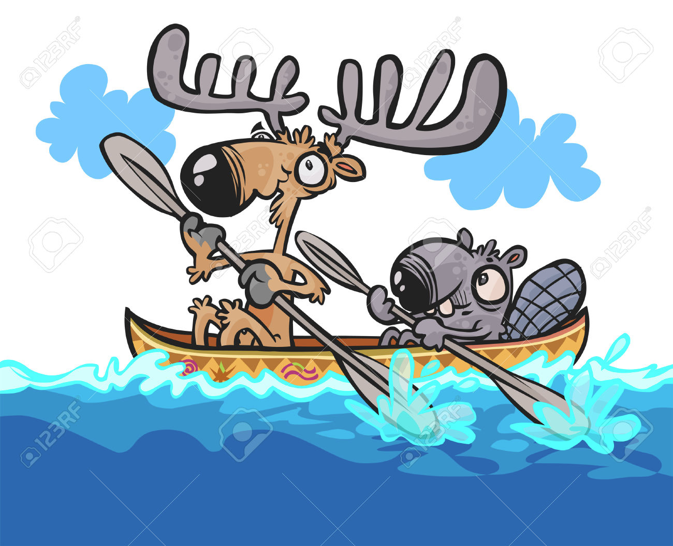

- What: A northern spring paddling camp. Involving technical, interval, and endurance components.

- Where: Solomon and Renee’s home on the Saskatchewan River.

- When: Friday May 20 5:00 arrivals. Departures Monday May 23 8:00 am.

- Why: To bring together friends and athletes to share in the sport of marathon canoe racing.

- How: Drive 16.5 km past E.B. Campbell Dam, which is situated on Highway 123 and approximately 4 hours north of Saskatoon. There will be people leaving from there starting at 5:00. You will be leaving your car there. You will be paddling into our place so bring your own boat, paddle, and lifejacket and paddle the four hours depending on your ability. You will be staying in one of our cabins. All sleeping bags are provided. If you need a canoe please contact us before and we will do our best to make one available. On Saturday and Sunday we will have various training sessions on land and on water including several small races so come ready to have some hard fun. We will be coming out early on Monday morning to get everyone on the road quickly.

- What to Bring: All your clothing for weather to cover wind, warm, cool, and rain. Your paddle and lifejacket. Bring a towel, hat, and personal items. We are planning a steak night on Saturday so bring your own steak, one potato, and one carrot. Sunday night will be pasta night, so whatever you want to bring. We will have some eggs and bacon for breakfast so please bring in your own breakfast goodies like eggs, cereal, milk, fruit, just for yourself. That is it. Please call us to ask any questions and for further information. We look forward to seeing you all.

- Renee & Solomon Carriere, Box 304 Cumberland House, 306.888.2104

